STEP 1: Upload the following Arduino Code

//=================================================

int ch_pd = 3;

int io0 = 2;

void setup() {

pinMode(ch_pd, OUTPUT);

pinMode(io0, OUTPUT);

digitalWrite(io0,LOW);

digitalWrite(ch_pd, LOW);

delay(1000);

digitalWrite(ch_pd, HIGH);

}

void loop() {

//BiarkanKosongsaja

}

//==================================================

STEP 2: Connect ESP8266-01 Module with Arduino as shown below

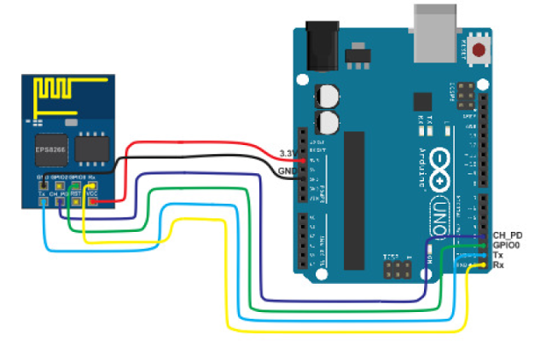

STEP 3: Go to FLASH_DOWNLOAD_TOOLS_v0.9.3.1 folder and open frame_test.exe

STEP 4: Choose the Firmware “v0.9.2.2 AT Firmware” from firmware folder

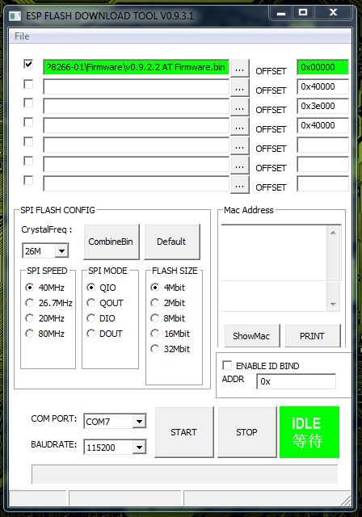

STEP 5: Select the Arduino COM PORT and click on START to upload firmware on ESP8266-01 module